** **

**A Gesture-based Tool for Sterile Browsing of Radiology Images**

**Team ID : PNT2022TMID16374**

**An IBM PROJECT REPORT**

***Submitted by***

**JUSTUS KEVIN T - (111919104052)**

**PRAVEEN G - (111919104098)**

**PRAVEEN V - (111919104099)**

**RAMANAN K - (111919104108*)***

***in partial fulfillment for the award of the degree***

***of***

**BACHELOR OF ENGINEERING**

**IN**

**COMPUTER SCIENCE AND ENGINEERING**

**S.A ENGINEERING COLLEGE, CHENNAI - 600 077**

**(AUTONOMOUS)**

**ANNA UNIVERSITY : CHENNAI 600 025. NOVEMBER 2022**

**INDEX**

**1. INTRODUCTION 4**

1.1 Project Overview 4

1.2 Purpose 4

**2. LITERATURE SURVEY 5**

2.1 Existing problem 5

2.2 References 5

2.3 Problem Statement Definition 9

**3. IDEATION & PROPOSED SOLUTION 12**

3.1 Empathy Map Canvas 12

3.2 Ideation & Brainstorming 12

3.3 Proposed Solution 19

3.4 Problem Solution fit 20

**4. REQUIREMENT ANALYSIS 21**

4.1 Functional requirements 21

4.2 Non-Functional requirements 22

**5. PROJECT DESIGN 23**

5.1Data Flow Diagrams 23

5.2 Solution & Technical Architecture 25

5.3 User Stories 26

**6. PROJECT PLANNING & SCHEDULING 28**

6.1Sprint Planning & Estimation 28

6.2 Sprint Delivery Schedule 29

6.3 Reports from JIRA 31

**7. CODING & SOLUTIONING 40**

7.1 Demo video 40

7.2 Home Header 40

7.3 Upload the image 40

7.4 Manipulate button 43

7.5 Resize the image to 200x200 size 47

7.6 Rotate the image 45 degree right 47

7.7 Blur the image 48

7.8 Resize the image to 400x400 size 48

7.9 Convert the image to grayscale 48

**8. TESTING 50**

8.1Test Cases 50

8.2 User Acceptance Testing 51

**9. RESULTS 54**

9.1 Performance Metrics 54

**10. ADVANTAGES & DISADVANTAGES 56**

**11. CONCLUSION 57**

**12. FUTURE SCOPE 58**

**13. APPENDIX 59**

Source Code 59

GitHub & Project Demo Link 98

**CHAPTER 1**

**INTRODUCTION**

**1.1 Project Overview**

In this project we use gestures to browse images obtained during radiology. Gestures refer to non verbal form of communication made using hands.

A major challenge involved in this process is to provide doctors with efficient, intuitive, accurate and safe means of interaction without affecting the quality of their work. Keyboards and pointing devices, such as a mouse, are today's principal method of human—computer interaction. However, the use of computer keyboards and mice by doctors and nurses in intensive care units (ICUs) is a common method for spreading infections. Humans can recognize body and sign language easily. This is possible due to the combination of vision and synaptic interactions that were formed along brain development.

In order to replicate this skill in computers, some problems need to be solved: how to separate objects of interest in images and which image capture technology and classification technique are more appropriate, among others. In this project Gesture based Desktop automation, First the model is trained pre trained on the images of different hand gestures, such as a showing numbers with fingers as 1,2,3,4. This model uses the integrated webcam to capture the video frame. The image of the gesture captured in the video frame is compared with the Pre-trained model and the gesture is identified. If the gesture predicts is 0 - then images is converted into rectangle, 1 - image is Resized into (200,200), 2 - image is rotated by -45॰, 3 - image is blurred, 4 - image is Resized into (400,400), 5 - image is converted into grayscale.

**1.2 Purpose**

It is used to browse through the images obtained using radiology using hand gestures rather than using mouse,keyboard,etc thereby maintaining sterility.

This interface prevented the surgeon's focus shift and change of location while achieving a rapid intuitive reaction and easy interaction. Data from two usability tests provide insights and implications regarding human-computer interaction based on nonverbal conversational modalities.

**CHAPTER 2**

**LITERATURE SURVEY**

**2.1 Existing problem**

A major challenge involved in gesture process is to provide doctors with efficient, intuitive, accurate and safe means of interaction without affecting the quality of their work. Keyboards and pointing devices, such as a mouse, are today's principal method of human—computer interaction. However, the use of computer keyboards and mice by doctors and nurses in intensive care units (ICUs) is a common method for spreading infections. Humans can recognize body and sign language easily. This is possible due to the combination of vision and synaptic interactions that were formed along brain development.

In order to replicate this skill in computers, some problems need to be solved: how to separate objects of interest in images and which image capture technology and classification technique are more appropriate, among others.

**2.2 References**

| **S.No** | **Article** | **Authors** | **Published Year** | **Abstract** |
| --- | --- | --- | --- | --- |
| 1 | Literature Survey on Hand Gesture Recognition System | Akshatha, Bhavani Patil, Harshitha, Sindhu shree | February 2020 | For those who are deaf and dumb Sign language is an efficient alternative way for talking, where we can understand them by using the hand gestures. For humans hands are a part of human organs which is used to manipulate physical objects. For this very reason hands are used most frequently by human beings to communicate and interact with machines. In the recent generation, hand gesture recognition system is improving in such a way that the interaction between the human and machine is advancing by using the electronic gadgets such as mobile phones, computers etc. So, there will be advancement not only in representing the speaking skills, also writing skills too. The real-time continuous gesture recognition is based on posture, position, orientation, and motion or by using the embedded systems like microcontrollers or it can be color maker approach, glove-based approach, vision-based approach and depth-based approach. The technique used in this system is that the input to the system will be given from the hand. They detect the image of the hand and pre-process it. Later on, they are going to crop the image how much they require for the analysis. In later stages they are going to extract the feature of the hand and then they are going to classify it. At the last the gesture is converted into the speech. According them hand gesture recognition system provides Human Computer Interaction. The two major applications they have used is Sign Language Recognition and gesture-based control. |
| 2 | Systematic literature review of hand gestures used in human computer interaction interfaces | ADEEN H.S,  ATIA A,  AMIN A,  VICTOR A,  ESSAM A,  GHARIB E  HUSSIEN | August 2015 | There are three sub-types of iconic gestures: those that describe a shape (Pictographs), those that represent a spatial relation (Spatiographic), and those that describe action of an object (Kinematographs) (Rimé and Schiaratura, 1991). Metaphoric gestures “are iconic gestures which represent abstract content” (Wagner et al., 2014, McNeill, 1992), e.g. a cutting gesture to indicate a decision has been made (Casasanto and Lozano, 2007). They “sketch in space the logical track followed by the speaker's thinking” (Rimé and Schiaratura, 1991). Modalizing symbolic gestures primarily complement speech, but can also complement other means of communication. |
| 3 | HAND GESTURE RECOGNITION : A LITERATURE REVIEW | Rafiqul Zaman Khan  Noor Adnan Ibraheem | July 2012 | Hand gesture recognition system received great attention in the recent few years because of itsmanifoldness applications and the ability to interact with machine efficiently through human computer interaction. In this paper a survey of recent hand gesture recognition systems is presented. Key issues of hand gesture recognition system are presented with challenges of gesture system. Review methods of recent postures and gestures recognition system presented as well. |
| 4 | Real-Time Hand Gesture Interface for Browsing Medical Images | Juan Wachs,  Helman Stern,  Yae lEdan,  Craig Feied,  Mark Smith  Jon | March 2007 | A gesture interface is developed for users, such as doctors/surgeons, to browse medical images in a sterile medical environment. A vision-based gesture capture system interprets user’s gestures in real-time to manipulate objects in an image visualization environment. A color distribution model of the gamut of colors of the users hand or glove is built at the start of each session resulting in an independent system. The gesture system relies on real-time robust tracking of the user’s hand based on a color-motion fusion model, in which the relative weight applied to the motion and color cues are adaptively determined according to the state of the system. Dynamic navigation gestures are translated to commands based on their relative positions on the screen. A state machine switches between other gestures such as zoom and rotate, as well as a sleep state. Performance evaluation included gesture recognition accuracy, task learning, and rotation accuracy. Fast task learning rates were found with convergence after ten trials. A beta test of a system prototype was conducted during a live brain biopsy operation, where neurosurgeons were able to browse through MRI images of the patient’s brain using the sterile hand gesture interface. The surgeons indicated the system was easy to use and fast with high overall satisfaction. |
| 5 | Gesture-controlled image system positioning for minimally invasive interventions | Hatsche rB,  Mewes A,  Pannicke E,  Kagebein U,  Wacker F,  Hansen C,  Hensel. | December 2020 | This work examines how a touchless interaction concept contributes to an efficient, direct, and sterile interaction workflow during CT-guided interventions. Twohand gesture sets were designed specifically under consideration of the clinical workflow and the hardware capabilities. These were used to change the position of an X-Ray tube and detector of a CT scanner without breakingsterility and are compared regarding usability and performance in a user study with 10 users. The user study revealed that it ispossible to change the angle of the gantry within 10 secondsaverage in an experimental setup. A straight hand gesture showed higher acceptance than a pistol motivated gesture. Furthermore, the sequences were not optimal and confused the users. It turned out that it feels more natural to activate and confirm the system with the same gesture. |

**2.3 Problem Statement Definition**

The Problem Statement helps you focus on what matters to create experiences people will love. A well-articulated problem statement allows you and your team to find the ideal solution for the challenges your customers face. Throughout the process, you’ll also be able to empathize with your customers, which helps you better understand how they perceive your product or service.

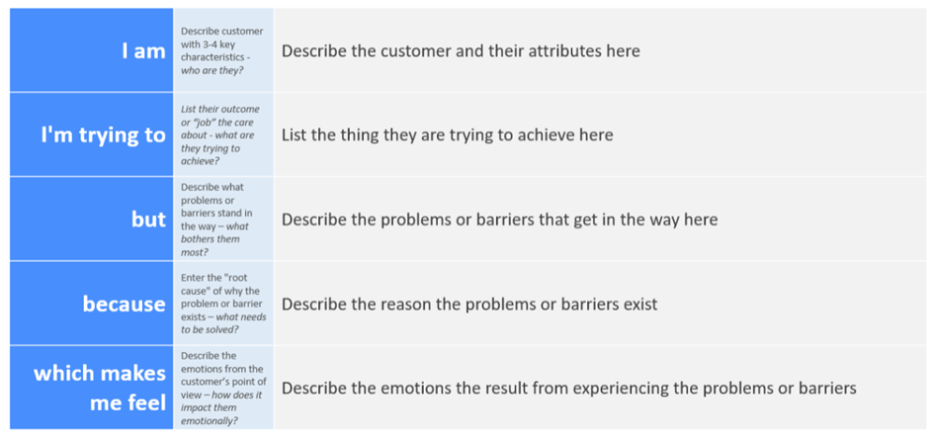

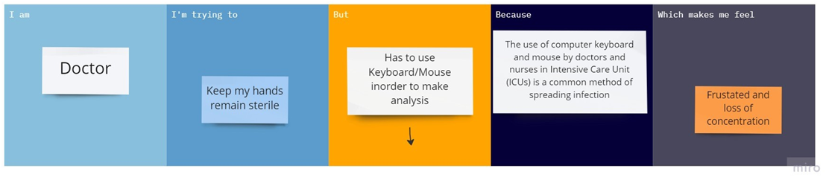

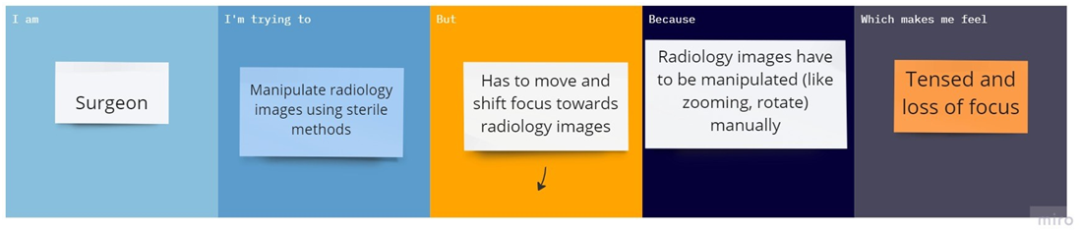

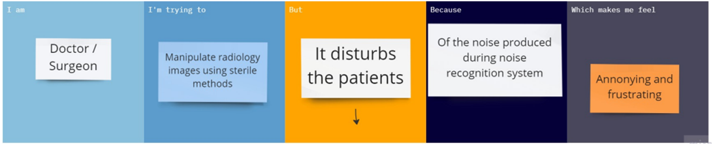

| **Problem Statement (PS)** | **Iam (Customer)** | **I’m trying to** | **But** | **Because** | **Which makes me feel** |
| --- | --- | --- | --- | --- | --- |
| PS-1 | Doctor | Keep my hands remain sterile | Has to use Keyboard/Mouse inorder to make analysis | The use of computer keyboard and mouse by doctors and nurses in Intensive Care Unit (ICUs) is a common method of spreading infection | Frustated and loss of concentration |
| PS-2 | Surgeon | Manipulate radiology images using sterile methods during surgery | Has to move and shift focus towards radiology images | Radiology images have to be manipulated (like zooming, rotate) manually | Tensed and loss of focus |
| PS-3 | Doctor/Surgeon | Manipulate radiology images using sterile methods | It disturbs the patients | Of the noise produced during noise recognition system | Annonying and frustrating |

**CHAPTER 3**

**IDEATION & PROPOSED SOLUTION**

**3.1 Empathy Map Canvas**

An empathy map is a simple, easy-to-digest visual that captures knowledge about a user’s behaviours and attitudes.

It is a useful tool to helps teams better understand their users.Creating an effective solution requires understanding the true problem and the person who is experiencing it. The exercise of creating the map helps participants consider things from the user’s perspective along with his or her goals and challenges.

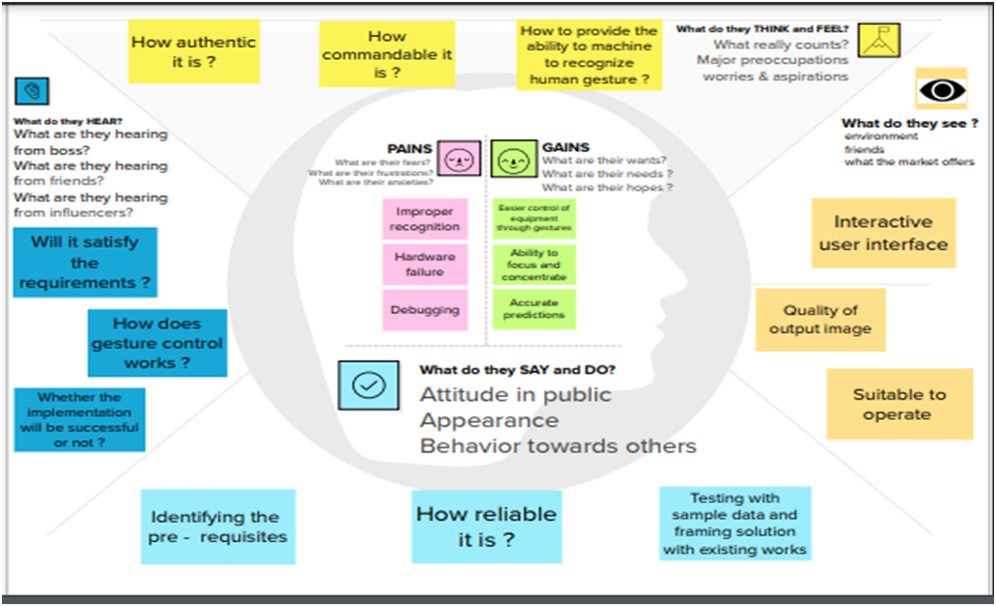

**3.2 Ideation & Brainstorming**

**Ideation**

In order to provide surgeons with a more efficient, comfortable, precise, and sterile interaction technique, the hands can be an effective means of accomplishing this goal in comparison to other modalities, such as voice or eye interaction . Touch-less gesture interaction is an option to interact with imaging systems, displays, and controllers without breaking the sterility barrier. The system utilizes nothing but a camera with good quality and can follow the hand of the user in 2 dimensions and identify up to four mouse-defined hand motions.

Recent progress in artificial intelligence provides innovative opportunities for motion tracking and human-machine interaction. In the field of healthcare, sensors like Microsoft Kinect has been used for detecting postures. And using electromyography technology to capture gesture instead of the camera, therefore it is less affected by the external factors such as light and obstruction.

Voice command is another type of touchless communication but its commands are discrete rather than hand gestures which are able to perform analog commands. On the other hand, voice command has other disadvantages such as its low accuracy due to existence of noise in surgery rooms and accents.

**Brainstorming**

Brainstorming provides a free and open environment that encourages everyone within a team to participate in the creative thinking process that leads to problem solving. Prioritizing volume over value, out-of-the-box ideas are welcome and built upon, and all participants are encouraged to collaborate, helping each other develop a rich amount of creative solutions.

This helps the team to unleash their imagination and start shaping concepts even if you're not sitting in the same room.

**Step-1: Team Gathering, Collaboration and Select the Problem Statement**

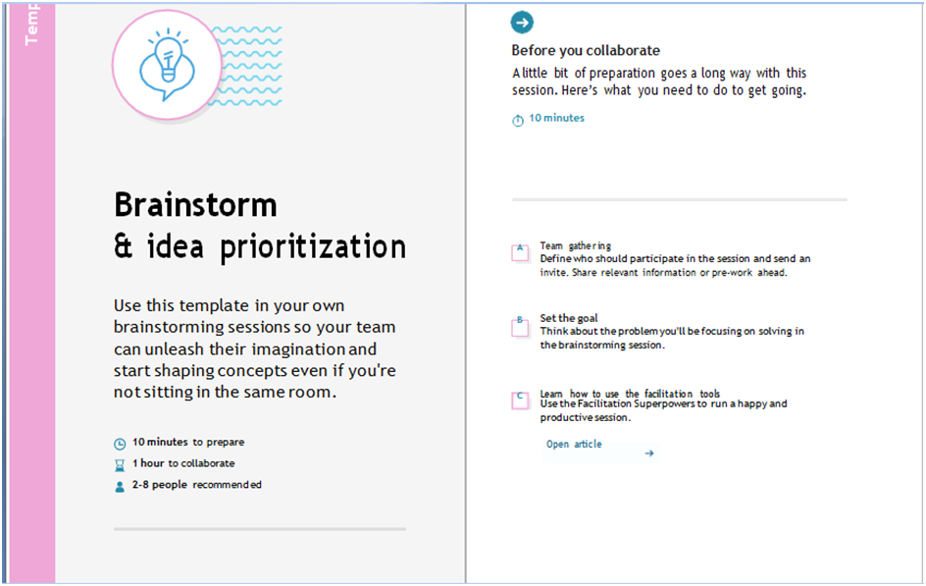

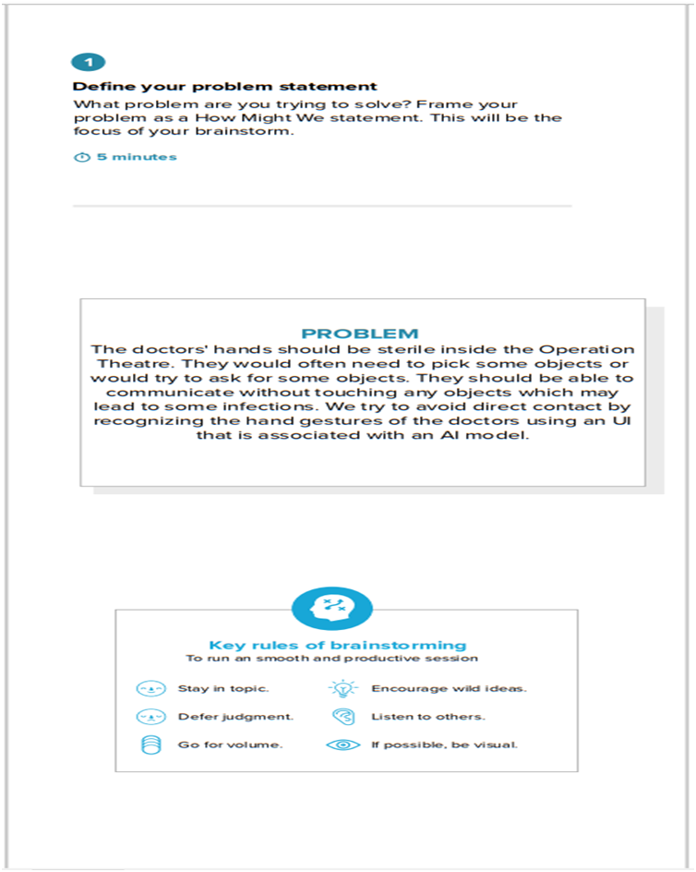

**Step-2: Brainstorm, Idea Listing and Grouping**

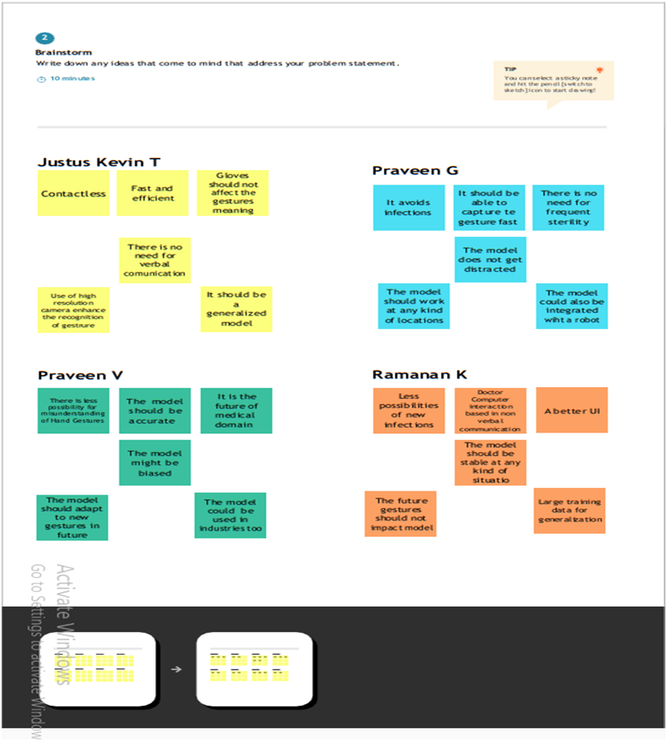

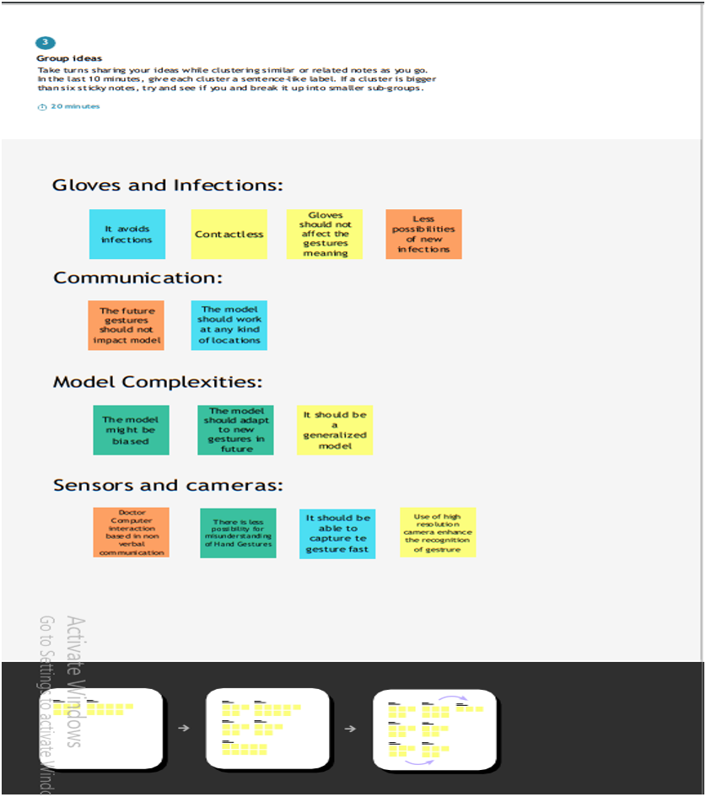

**Step-3: Idea Prioritization**

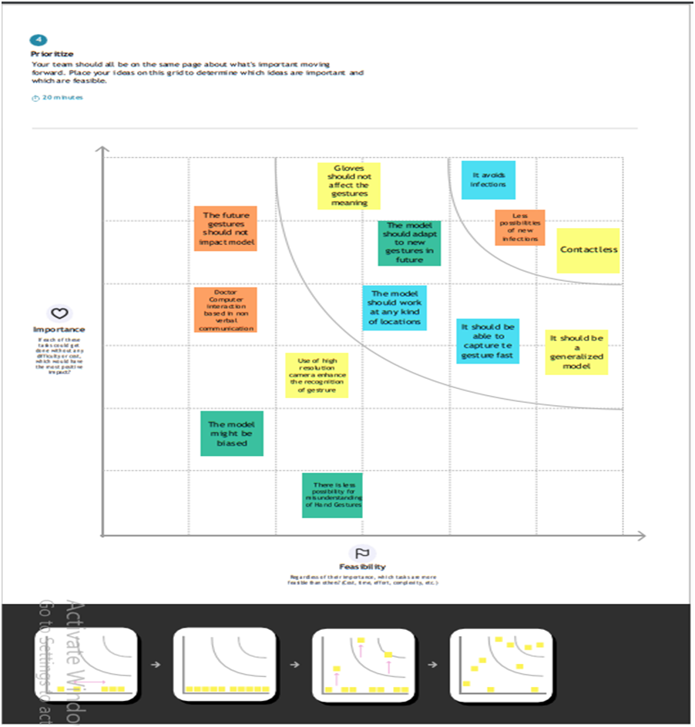

**3.3 Proposed Solution**

| **S.No.** | **Parameter** | **Description** |
| --- | --- | --- |
| 1. | Problem Statement (Problem to be solved) | Hand Gesture tool to do sterile navigation of radiology images |
| 2. | Idea / Solution description | Use artificial intelligence technology to assist doctors by taking hand gestures as input and perform necessary actions on radiology images |
| 3. | Novelty / Uniqueness | These Gestures helps to manipulate the radiology images and helps to stay focused for surgeons. |
| 4. | Social Impact / Customer Satisfaction | The proposed system should provide a good manipulation of radiology images for surgeon during surgery supporting their focus of attention, and providing fast response times. |
| 5. | Business Model (Revenue Model) | A Hand-based Gesture Recognition System used for detecting any kind of Gestures which when the given input Gesture matches with the trained image. |
| 6. | Scalability of the Solution | The proposed approach allows the learning of new gestures with no need of recording real subjects. |

**3.4 Problem Solution fit**

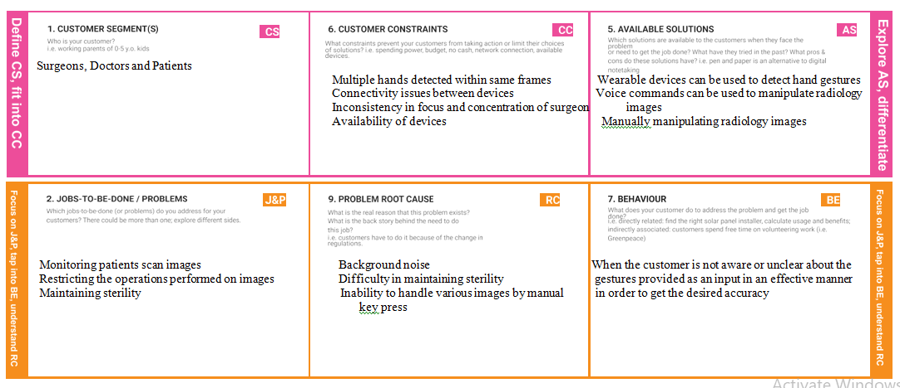

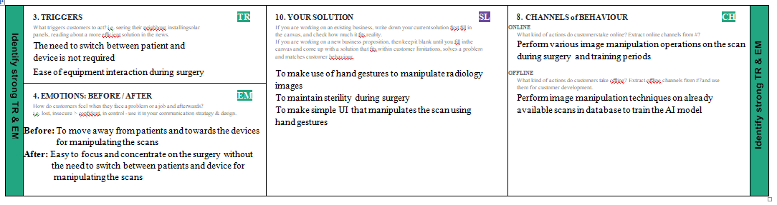

**CHAPTER 4**

**REQUIREMENT ANALYSIS**

**4.1 Functional requirements**

| **FR No.** | **Functional Requirement (Epic)** | **Sub Requirement (Story / Sub-Task)** |
| --- | --- | --- |
| FR-1 | Hand detection | Filtering of hand from video capturing device |
| FR-2 | Filtered object detection | Reads and filters by recognizing clusters of skin coloured objects |
| FR-3 | Gesture control | Hand gestures recognition for commands |
| FR-4 | Hand calibration | Perform according to the adjustment of user’s dominant hand |
| FR-5 | Model rendering | When the user uploads/gives the gestures, the algorithm should start processing its task. |
| FR-6 | Launching the model | Launch the application either from cloud where it is deployed or by installation but with a stable internet connectivity |

**4.2 Non-Functional requirements**

| **FR No.** | **Non-Functional Requirement** | **Description** |
| --- | --- | --- |
| NFR-1 | Usability | Usability is easy for all users. It is understandable for non technical users with minimal instructions |
| NFR-2 | Security | Accessible only in secure networks with administrative permissions, so there is less chance of security breach |
| NFR-3 | Reliability | It is operable under all conditions, regardless of user’s operating environment |
| NFR-4 | Performance | Minimize the number of calculation to perform hand gesture and to improve image resolution quality |
| NFR-5 | Availability | When the gesture is available then only the application works. This application is only available in surgery rooms |
| NFR-6 | Scalability | Model is scaled by CNN with help of data augmentation and gesture recognition using OpenCV, Tensorflow, Keras |

**CHAPTER 5**

**PROJECT DESIGN**

**5.1 Data Flow Diagrams**

A Data Flow Diagram (DFD) is a traditional visual representation of the information flows within a system. A neat and clear DFD can depict the right amount of the system requirement graphically. It shows how data enters and leaves the system, what changes the information, and where data is stored.

**Simplified**

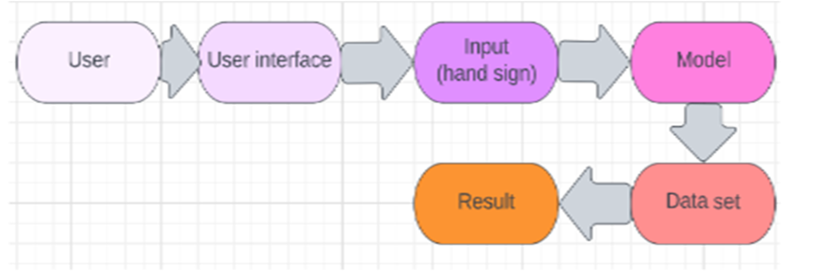

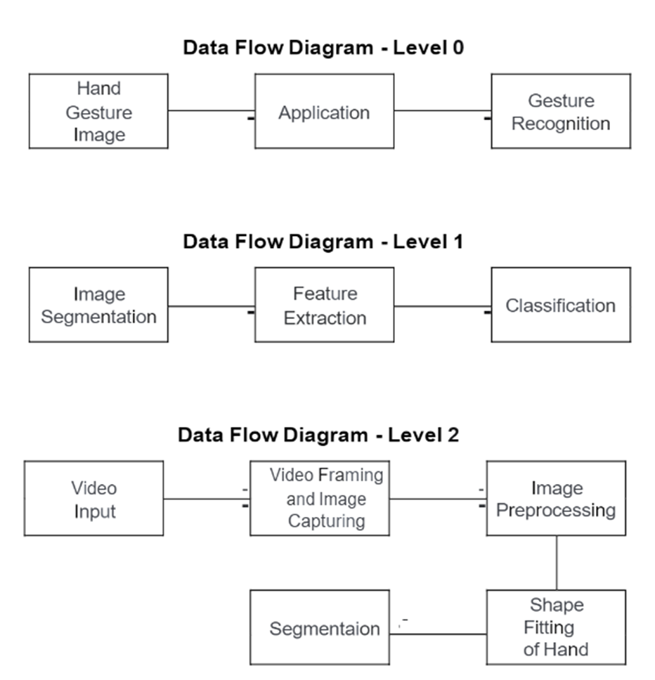

**5.2 Solution & Technical Architecture**

**Technical Architecture**

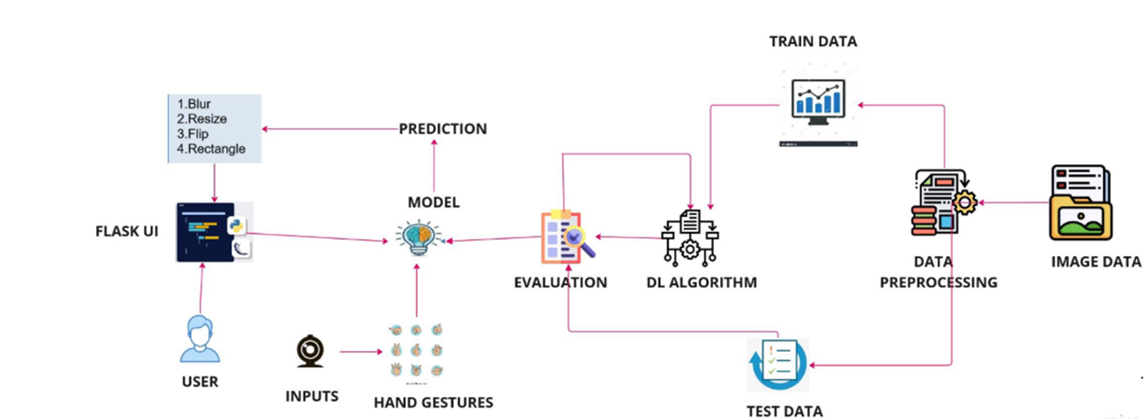

**Solution Architecture**

Solution architecture is a complex process – with many sub-processes – that bridges the gap between business problems and technology solutions. Its goals are to:

* Find the best tech solution to solve existing business problems.
* Describe the structure, characteristics, behavior, and other aspects of the software to project stakeholders.
* Define features, development phases, and solution requirements.
* Provide specifications according to which the solution is defined, managed, and delivered.

# **Solution architecture for a gesture based tool for sterile browsing of radiology images.**

1. User (Doctor/Surgeon) is giving hand gestures as input to perform the certain actions such as zoom in, zoom out the image of the patients during the surgery.

2. In this project Gesture based project, First the model is trained, pre trained on the images of different hand gestures,

3. This model uses the integrated webcam to capture the video frame. The image of the gesture captured in the video frame is compared with the pre-trained model and the gesture is identified.

4. If the gesture predicate is 1 then images is resized into 200x200; 2. image is rotated to 45 degree right side; 3. image is blurred; 4. Image is resized into 400x400; 5. Image is converted to greyscale.

**Solution Architecture**

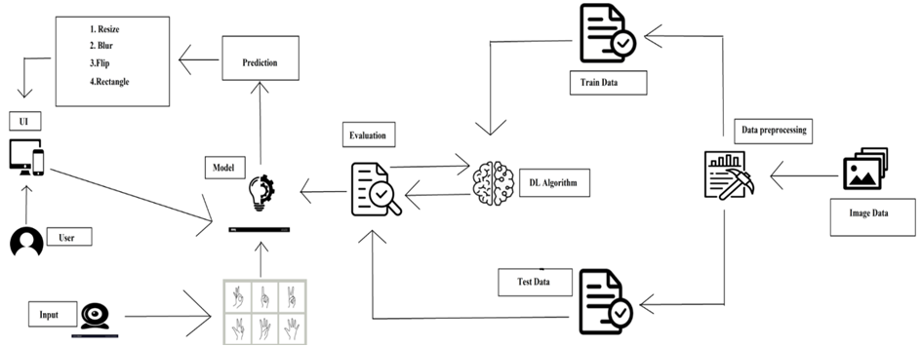

**5.3 User Stories**

| **User Type** | **Functional Requirement (Epic)** | **User Story Number** | **User Story / Task** | **Acceptance criteria** | **Priority** | **Release** |
| --- | --- | --- | --- | --- | --- | --- |
| Customer [Doctor/Surgeon]  (Web user) | Launch | USN-1 | As a user I can launch the webpage to upload and manipulate the scan images | I can access the webpage | High | Sprint-4 |
|  |  | USN-2 | As a user I can use different web browsers | I can access the webpage using different web browsers | High | Sprint-1 |
| Administrator | IBM Cloud | USN-1 | Access the database | Database Management | High | Sprint-3 |
|  |  | USN-2 | Server crash, database recovery | Resolve the errors/ issue, recover the lost data from database | High | Sprint-5 |
| Customer care executive | Availability | USN-1 | Interpret and recognize gesture inaccurately | Webcam detection | Medium | Sprint-5 |
|  |  | USN-2 | When the website is unresponsive or an internal error occurs in the website | Webpage is unresponsive | Medium | Sprint-4 |

**CHAPTER 6**

**PROJECT PLANNING & SCHEDULING**

**6.1 Sprint Planning & Estimation**

| **Sprint** | **Functional Requirement (Epic)** | **User Story Number** | **User Story / Task** | **Story Points** | **Priority** | **Team Members** |
| --- | --- | --- | --- | --- | --- | --- |
| Sprint-1 | Application/Software Launch | USN-1 | As a user, I can launch the developed application/software | 10 | Medium | Praveen V  Ramanan K  Praveen G  Justus Kevin T |
| Sprint-1 | Accessing the User Interface (UI) | USN-2 | As a user, I can interact with software and operate the application with the help of UI | 10 | Medium | Praveen V  Ramanan K  Praveen G  Justus Kevin T |
| Sprint-2 | Launching the webcam/camera | USN-3 | As a user, I can open the webcam/camera from the application to perform gestures | 12 | Low | Praveen V  Ramanan K  Praveen G  Justus Kevin T |
| Sprint-2 | Upload images from local system for manipulation | USN-4 | As a user, I can upload images to the application from local system for manipulation | 18 | Low | Praveen V  Ramanan K  Praveen G  Justus Kevin T |
| Sprint-3 | Manipulating images through gestures | USN-5 | As a user, I can perform various gestures with respect to system specification to manipulate the images | 20 | Medium | Praveen V  Ramanan K  Praveen G  Justus Kevin T |
| Sprint-4 | Display the result/output | USN-6 | As a user, I can see the sterile browsed/manipulated image on the screen with respect to the gesture performed | 20 | High | Praveen V  Ramanan K  Praveen G  Justus Kevin T |

**6.2 Sprint Delivery Schedule**

| **SI. NO** | **MILESTONE** | **ACTIVITIES** | **DATE** |
| --- | --- | --- | --- |
| 1 | Preparation Phase | Pre-requisites | 24 Aug 2022 |
| Prior knowledge | 25 Aug 2022 |
| Project Structure | 23 Aug 2022 |
| Project Flow | 23 Aug 2022 |
| Project Objectives | 22 Aug 2022 |
| Registrations | 26 Aug 2022 |
| Environment Set-up | 27 Aug 2022 |
| 2 | Ideation Phase | Literature Survey | 29 Aug 2022 -  03 Sept 2022 |
| Empathy Map | 5 Sept 2022 -  7 Sept 2022 |
| Problem Statement | 8 Sept 2022 –  10 Sept 2022 |
| Ideation | 12 Sept 2022-  16 Sept 2022 |
| 3 | Project Design Phase -I | Proposed Solution | 19 Sept 2022 –  23 Sept 2022 |
| Problem Solution Fit | 24 Sept 2022 –  26 Sept 2022 |
| Solution Architecture | 27 Sept 2022 –  30 Sept 2022 |
| 4 | Project Design Phase -II | Customer Journey | 3 Oct 2022 –  8 Oct 2022 |
| Requirement Analysis | 9 Oct 2022 –  11 Oct 2022 |
| Data Flow Diagrams | 11 Oct 2022 –  14 Oct 2022 |
| Technology Architecture | 15 Oct 2022 –  16 Oct 2022 |
| 5 | Project Planning Phase | Milestones & Tasks | 17 Oct 2022 –  18 Oct 2022 |
| Sprint Schedules | 19 Oct 2022-  22 Oct 2022 |
| 6 | Project Development Phase | Sprint-1 | 24 Oct 2022 -  29 Oct 2022 |
| Sprint-2 | 31 Oct 2022 -  05 Nov 2022 |
| Sprint-3 | 07 Nov 2022 -  12 Nov 2022 |
| Sprint-4 | 14 Nov 2022 -  19 Nov 2022 |

**6.3 Reports from JIRA**

**Burndown Chart**

**Burndown Chart for Sprint 1**

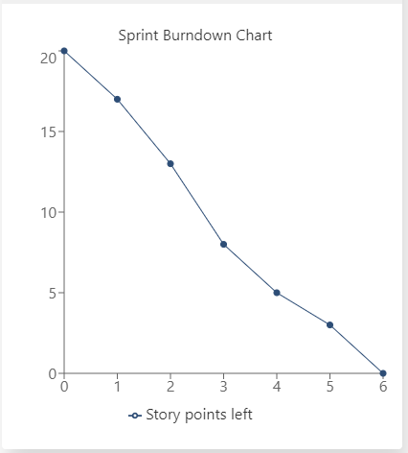

**Burndown Chart for Sprint 2**

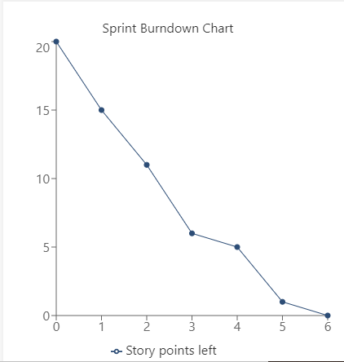

**Burndown Chart Sprint 3**

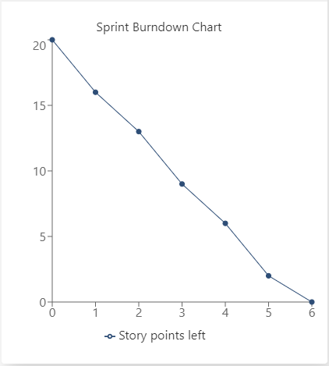

**Burndown Chart Sprint 4**

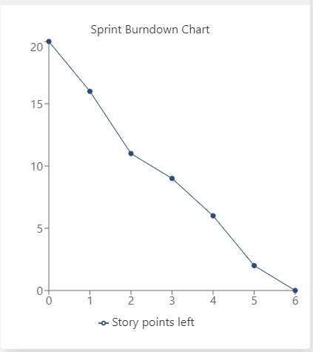

**Velocity Chart**

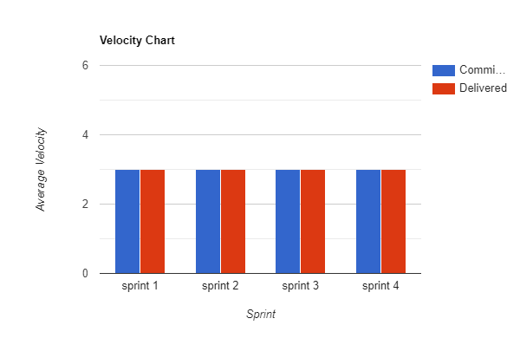

**Burnup Chart**

**Burnup Chart for Sprint 1 - Sprint 4**

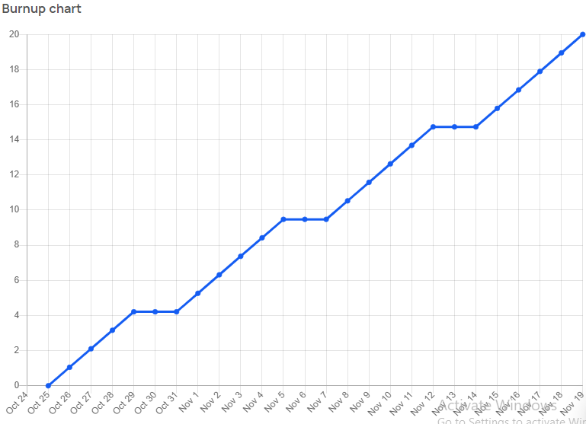

**Sprint Report**

**Sprint 1**

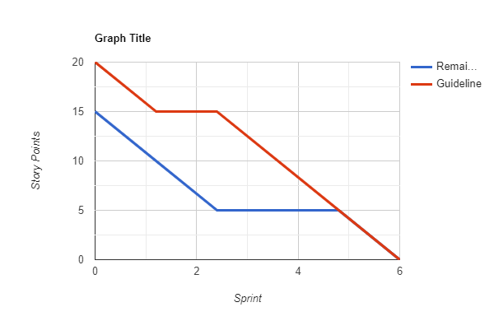

**Sprint 2**

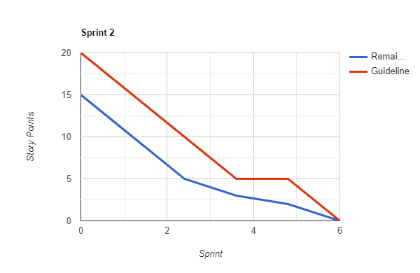

**Sprint 3**

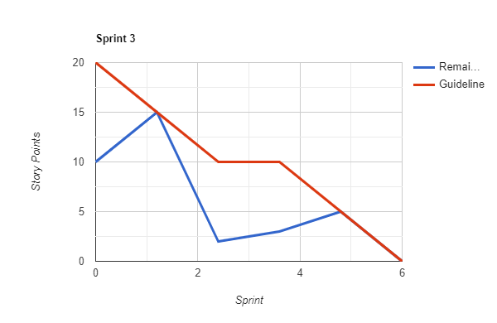

**Sprint 4**

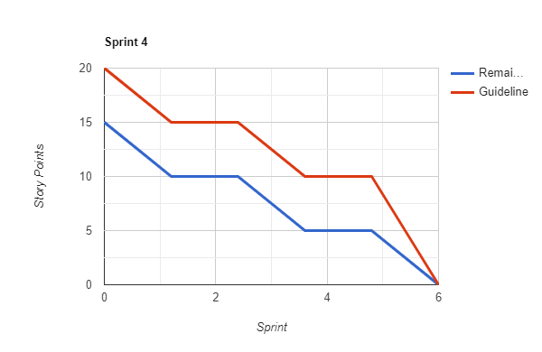

**CHAPTER 7**

**CODING & SOLUTIONING**

**7.1 Demo video**

The demo video is found on the demo page and can be accessed through the link <https://127.0.0.1:5000/demo> or <https://127.0.0.1:5000/> and click on demo

This demo video showcases the browsing of radiology images through sterile methodology of gesture based

<iframe width="780" height="440" src="https://www.youtube.com/embed/nD621G8u6oc?start=3&loop=1&autoplay=1&mute=1&controls=0">

</iframe><br/>

**7.2 Home header**

The home header is found on the top of home page and can be accessed through the link <https://127.0.0.1:5000/>

This home header leads to the smartinternzl page of the projet when the header is clicked

<a href="https://smartinternz.com/guided-project/a-gesture-based-tool-for-sterile-browsing-of-radiology-images-cnn-and-open-cv">

<h2> Gesture-based Tool for Sterile Browsing of Radiology Images</h2>

</a>

**7.3 Upload the image**

The upload image feature is found in launch page and can be accessed through the link <https://127.0.0.1:5000/launch> or <https://127.0.0.1:5000/> and click on launch

This feature is used to upload the image which is going to be manipulated

<form action = "http://localhost:5000/" id="upload-file" method="post" enctype="multipart/form-data">

<br>

<div class="upload">

<label><i class="fa fa-upload" style="font-size: 50px; "aria-hidden="true"><input type="file" style="display:none;" name="image" id="imageUpload" accept=".png, .jpg, .jpeg,.pdf"></i></label>

</div><br><br>

</form>

.upload{

border: 1px solid black;

border-radius: 50%;

padding: 20px;

background-color: white;

}

$(document).ready(function () {

// Init

$('.image-section').hide();

$('.loader').hide();

$('#result').hide();

// Upload Preview

function readURL(input) {

if (input.files && input.files[0]) {

var reader = new FileReader();

reader.onload = function (e) {

$('#imagePreview').css('background-image', 'url(' + e.target.result + ')');

$('#imagePreview').hide();

$('#imagePreview').fadeIn(650);

}

reader.readAsDataURL(input.files[0]);

}

}

$("#imageUpload").change(function () {

$('.image-section').show();

$('#btn-predict').show();

$('#result').text('');

$('#result').hide();

readURL(this);

});

**7.4 Manipulate button**

It is found in launch page and can be accessed via <https://127.0.0.1:5000/> and click on launch or <https://127.0.0.1:5000/launch>

It is used to start the manipulation of uploaded image through opencv2

<div class="image-section" style="display:none;">

<div class="img-preview">

<div id="imagePreview">

</div>

</div>

<div>

<button type="button" class="btn btn-info btn-lg " id="btn-predict">Manipulate</button>

</div>

</div>

<div class="loader" style="display:none;"></div>

</div>

</div1>

<footer>

<script src="{{ url_for('static', filename='js/main.js') }}" type="text/javascript"></script>

</footer>

.img-preview {

width: 256px;

height: 256px;

position: relative;

border: 5px solid #F8F8F8;

box-shadow: 0px 2px 4px 0px rgba(0, 0, 0, 0.1);

margin-top: 1em;

margin-bottom: 1em;

}

.img-preview>div {

width: 100%;

height: 100%;

background-size: cover;

background-repeat: no-repeat;

background-position: center;

}

.loader {

border: 8px solid #f3f3f3; /* Light grey */

border-top: 8px solid #3498db; /* Blue */

border-radius: 50%;

width: 50px;

height: 50px;

animation: spin 1s linear infinite;

button {

background-color: #091425;

color: black;

padding: 14px 20px;

margin-bottom:10px;

border: none;

cursor: pointer;

width: 17%;

border-radius:4px;

font-family:Montserrat;

}

button:hover {

opacity: 0.8;

}

.button:hover {

box-shadow: 0 12px 16px 0 rgba(0,0,0,0.24), 0 17px 50px 0 rgba(0,0,0,0.19);

}

// Predict

$('#btn-predict').click(function () {

var form_data = new FormData($('#upload-file')[0]);

// Show loading animation

$(this).hide();

$('.loader').show();

// Make prediction by calling api /predict

$.ajax({

type: 'POST',

url: '/perform',

data: form_data,

contentType: false,

cache: false,

processData: false,

async: true,

success: function (data) {

// Get and display the result

$('.loader').hide();

$('#result').fadeIn(600);

$('#result').html(data);

console.log('Success!');

},

});

});

});

**7.5 Resize image to 200x200 size**

This feature resizes the image size to 200x200. This is achieved by showing 1 finger infront of webcam while manipulating the image

if prediction[0][0]=='ONE':

resized = cv2.resize(image1, (200, 200))

cv2.imshow("Fixed Resizing", resized)

key=cv2.waitKey(3000)

if (key & 0xFF) == ord("1"):

cv2.destroyWindow("Fixed Resizing")

**7.6 Rotate image by 45 degree right**

This feature rotates the image 45 degree to right. This is achieved by showing 2 fingers infront of webcam while manipulating the image

elif prediction[0][0]=='TWO':

(h, w, d) = image1.shape

center = (w // 2, h // 2)

M = cv2.getRotationMatrix2D(center, -45, 1.0)

rotated = cv2.warpAffine(image1, M, (w, h))

cv2.imshow("OpenCV Rotation", rotated)

key=cv2.waitKey(3000)

if (key & 0xFF) == ord("2"):

cv2.destroyWindow("OpenCV Rotation")

**7.7 Blur the image**

This feature blurs the uploaded image. This is achieved by showing 3 fingers infront of webcam while manipulating the image

elif prediction[0][0]=='THREE':

blurred = cv2.GaussianBlur(image1, (21, 21), 0)

cv2.imshow("Blurred", blurred)

key=cv2.waitKey(3000)

if (key & 0xFF) == ord("3"):

cv2.destroyWindow("Blurred")

**7.8 Resize the image to 400x400 size**

This feature resizes the uploaded image to the size 0f 400x400. This is achieved by showing 4 fingers infront of webcam while manipulating the image

elif prediction[0][0]=='FOUR':

resized = cv2.resize(image1, (400, 400))

cv2.imshow("Fixed Resizing", resized)

key=cv2.waitKey(3000)

if (key & 0xFF) == ord("4"):

cv2.destroyWindow("Fixed Resizing")

**7.9 Convert the image to grayscale**

This feature converts the uploaded image to grayscale image. This is achieved by showing 5 fingers infront of webcam while manipulating the image

elif prediction[0][0]=='FIVE':

gray = cv2.cvtColor(image1, cv2.COLOR_RGB2GRAY)

cv2.imshow("OpenCV Gray Scale", gray)

key=cv2.waitKey(3000)

if (key & 0xFF) == ord("5"):

cv2.destroyWindow("OpenCV Gray Scale")

**CHAPTER 8**

**TESTING**

**8.1 Test Cases**

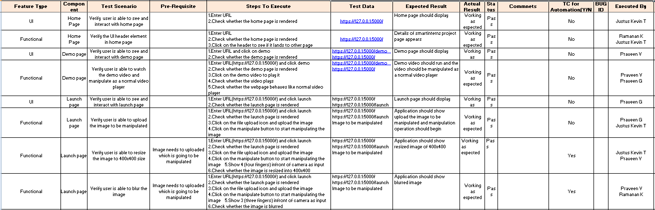

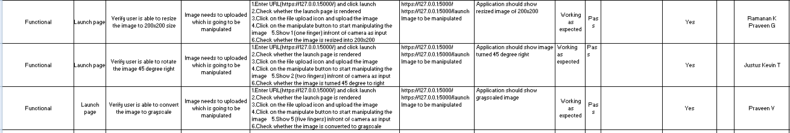

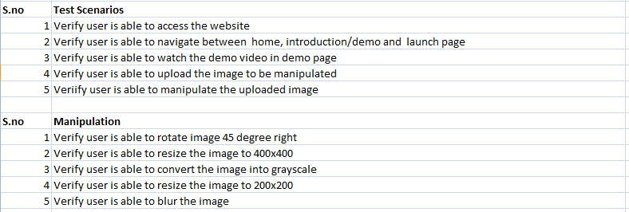

**8.2 User Acceptance Testing**

**Purpose**

It is to briefly explain the test coverage and open issues of the A Gesture-based Tool for Sterile Browsing of Radiology Image project at the time of the release to User Acceptance Testing (UAT).

**Defect Analysis**

This report shows the number of resolved or closed bugs at each severity level, and how they were resolved

| **Resolution** | **Severity1** | **Severity2** | **Severity3** | **Severity4** | **Subtotal** |
| --- | --- | --- | --- | --- | --- |
| By Design | 6 | 4 | 3 | 5 | 18 |
| Duplicate | 1 | 2 | 1 | 0 | 4 |
| External | 2 | 3 | 0 | 2 | 7 |
| Fixed | 11 | 2 | 3 | 13 | 29 |
| Not Reproduced | 0 | 1 | 1 | 1 | 3 |
| Skipped | 0 | 0 | 2 | 2 | 4 |
| Won't Fix | 0 | 4 | 2 | 2 | 8 |
| Totals | 20 | 16 | 12 | 25 | 73 |

**Test Case Analysis**

This report shows the number of test cases that have passed, failed, and untested

| **Section** | **TotalCases** | **Not Tested** | **Fail** | **Pass** |
| --- | --- | --- | --- | --- |
| Print Engine | 9 | 0 | 0 | 9 |
| Client Application | 45 | 0 | 5 | 40 |
| Security | 5 | 0 | 1 | 4 |
| Outsource Shipping | 3 | 0 | 0 | 3 |
| Exception Reporting | 8 | 2 | 1 | 5 |
| Final Report Output | 10 | 1 | 2 | 7 |
| Version Control | 3 | 0 | 0 | 3 |

**CHAPTER 9**

**RESULTS**

**9.1 Performance Metrics**

**Model Performance Testing**

| **S.No.** | **Parameter** | **Values** | **Screenshot** |
| --- | --- | --- | --- |
| 1. | Model Summary | **-** |  |
| 2. | Accuracy | Training Accuracy - 0.9798  Validation Accuracy - 0.9667 |  |

**CHAPTER 10**

**ADVANTAGES & DISADVANTAGES**

**Advantages**

* Major advantage of this tool is that it helps to maintain the sterility of the environment.
* It is also easy to use and is quicker than the existing methods to browse images.
* It can also be performed even if the surgeon is a bit far away from the system, this helps to save time.
* The tool does not need the person using it to have an apparatus or any devices on them to use it.
* The Hand Gesture Recognition system provides a natural way of interfacing with the computers; hence it is more User friendly..
* There is less wear and tear of the computer as the standard input devices are eliminated and a camera is used as an input device.

**Disadvantages**

* The tool can be quite expensive as it requires cameras and other expensive devices to capture images and process it.
* Such systems are difficult to develop because of their complexity and their cost of implementation.
* As each gesture is assigned a specific control command, this system is not platform independent since certain control commands vary as the operating system varies.

**CHAPTER 11**

**CONCLUSION**

In this project a tool is developed which recognises hand gestures and enables doctors to browse through radiology images using these gestures. This enables doctors and surgeons to maintain the sterility as they would not have to touch any mouse or keyboard to go through the images. This tool is also easy to use and is quicker than the regular method of using mouse/keyboard. It can be used regardless of the users location since they don’t have to be in contact with any device. It also does not require the user to have any device on them to use it. Further this technology can be extended to other industries like it can be used by presenters, by teachers for show images in the classroom, etc.

**CHAPTER 12**

**FUTURE SCOPE**

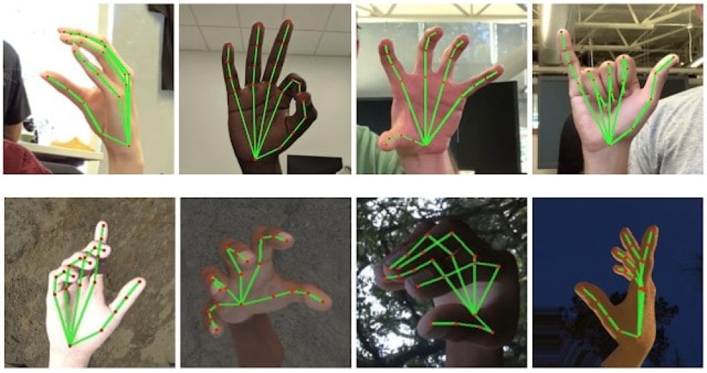

The tool can be made to add multiple images to be uploaded and predict the output for the particular image. For that, user can choose any image from the multiple images and apply the prediction for the respective image for manipulation.

The tool can be made quicker by increasing the recognition speed. More number of gestures can be added thereby increasing this tool’s functionality and useability for different purposes. Tracking of both hands can be added to increase the set of commands. Voice commands can also be added to further increase the functionality.

**CHAPTER 13**

**APPENDIX**

**Source Code**

**Image_preprocessing.py:**

"""Importing Libraries """

import os

from tensorflow.keras.preprocessing.image import ImageDataGenerator

"""Configuring the ImageDataGenerator Class"""

train_data_generator1 = ImageDataGenerator(rescale=1.0/255,horizontal_flip=True)

test_data_generator1 = ImageDataGenerator(rescale=1.0/255, horizontal_flip=True)

train_data_generator2 = ImageDataGenerator(rescale=1.0/255,rotation_range=90)

test_data_generator2 = ImageDataGenerator(rescale=1.0/255,rotation_range=90)

train_data_generator3 = ImageDataGenerator(rescale=1.0/255,brightness_range=[0.2,1.0])

test_data_generator3 = ImageDataGenerator(rescale=1.0/255,brightness_range=[0.2,1.0])

train_data_generator4 = ImageDataGenerator(rescale=1.0/255,zoom_range=[0.5,1.0])

test_data_generator4 = ImageDataGenerator(rescale=1.0/255,zoom_range=[0.5,1.0])

"""Applying ImageDataGenerator to test dataset and train dataset"""

trdata1 = train_data_generator1.flow_from_directory(r'D:\College\7th semester\ibm\Project Development Phase\Sprint 1\Data collection\Dataset\train',target_size=(64,64),batch_size=(3),color_mode='grayscale',class_mode='categorical')

trdata2 = train_data_generator2.flow_from_directory(r'D:\College\7th semester\ibm\Project Development Phase\Sprint 1\Data collection\Dataset\train',target_size=(64,64),batch_size=(3),color_mode='grayscale',class_mode='categorical')

trdata3 = train_data_generator3.flow_from_directory(r'D:\College\7th semester\ibm\Project Development Phase\Sprint 1\Data collection\Dataset\train',target_size=(64,64),batch_size=(3),color_mode='grayscale',class_mode='categorical')

trdata4 = train_data_generator4.flow_from_directory(r'D:\College\7th semester\ibm\Project Development Phase\Sprint 1\Data collection\Dataset\train',target_size=(64,64),batch_size=(3),color_mode='grayscale',class_mode='categorical')

tsdata1 = test_data_generator1.flow_from_directory(r'D:\College\7th semester\ibm\Project Development Phase\Sprint 1\Data collection\Dataset\test',target_size=(64,64),batch_size=32,class_mode='categorical',color_mode='grayscale')

tsdata2 = test_data_generator2.flow_from_directory(r'D:\College\7th semester\ibm\Project Development Phase\Sprint 1\Data collection\Dataset\test',target_size=(64,64),batch_size=32,class_mode='categorical',color_mode='grayscale')

tsdata3 = test_data_generator3.flow_from_directory(r'D:\College\7th semester\ibm\Project Development Phase\Sprint 1\Data collection\Dataset\test',target_size=(64,64),batch_size=32,class_mode='categorical',color_mode='grayscale')

tsdata4 = test_data_generator4.flow_from_directory(r'D:\College\7th semester\ibm\Project Development Phase\Sprint 1\Data collection\Dataset\test',target_size=(64,64),batch_size=32,class_mode='categorical',color_mode='grayscale')

print(trdata1.class_indices)

print(trdata2.class_indices)

print(trdata3.class_indices)

print(trdata4.class_indices)

print(tsdata1.class_indices)

print(tsdata2.class_indices)

print(tsdata3.class_indices)

print(tsdata4.class_indices)

**App.py:**

from flask import Flask,render_template,request

# Flask-It is our framework which we are going to use to run/serve our application.

#request-for accessing file which was uploaded by the user on our application.

import operator

import cv2 # opencv library

import matplotlib.pyplot as plt

import matplotlib.image as mpimg

import numpy as np

from tensorflow.keras.models import load_model #to load our trained model

import os

from werkzeug.utils import secure_filename

app = Flask(__name__,template_folder="templates") # initializing a flask app

# Loading the model

model=load_model('gesture.h5')

@app.route('/')# route to display the home page

def home():

return render_template('home1.html')#rendering the home page

@app.route('/demo',methods=['GET','POST']) # routes to the intro page

def demo():

return render_template('demo.html')#rendering the intro page

@app.route('/launch',methods=['GET','POST'])

def launch():

return render_template("launch.html")

@app.route('/perform',methods=['GET', 'POST'])# route to show the predictions in a web UI

def perform():

if request.method == 'POST':

print("inside image")

file_loader = request.files['image']

basepath = os.path.dirname(__file__)

file_path = os.path.join(basepath, 'uploads', secure_filename(file_loader.filename))

file_loader.save(file_path)

print(file_path)

cap = cv2.VideoCapture(0)

while True:

_, frame = cap.read() #capturing the video frame values

# Simulating mirror image

frame = cv2.flip(frame, 1)

# Coordinates of the ROI

x1 = int(0.5*frame.shape[1])

y1 = 10

x2 = frame.shape[1]-10

y2 = int(0.5*frame.shape[1])

# Drawing the ROI

# The increment/decrement by 1 is to compensate for the bounding box

cv2.rectangle(frame, (x1-1, y1-1), (x2+1, y2+1), (255,0,0) ,1)

# Extracting the ROI

roi = frame[y1:y2, x1:x2]

# Resizing the ROI so it can be fed to the model for prediction

roi = cv2.resize(roi, (64, 64))

roi = cv2.cvtColor(roi, cv2.COLOR_BGR2GRAY)

_, test_image = cv2.threshold(roi, 120, 255, cv2.THRESH_BINARY)

cv2.imshow("test", test_image)

# Batch of 1

result = model.predict(test_image.reshape(1, 64, 64, 1))

prediction = {'ZERO': result[0][0],

'ONE': result[0][1],

'TWO': result[0][2],

'THREE': result[0][3],

'FOUR': result[0][4],

'FIVE': result[0][5]}

# Sorting based on top prediction

prediction = sorted(prediction.items(), key=operator.itemgetter(1), reverse=True)

# Displaying the predictions

cv2.putText(frame, prediction[0][0], (10, 120), cv2.FONT_HERSHEY_PLAIN, 1, (0,255,255), 1)

cv2.imshow("Frame", frame)

#loading an image

image1=cv2.imread(file_path)

if prediction[0][0]=='ONE':

resized = cv2.resize(image1, (200, 200))

cv2.imshow("Fixed Resizing", resized)

key=cv2.waitKey(3000)

if (key & 0xFF) == ord("1"):

cv2.destroyWindow("Fixed Resizing")

elif prediction[0][0]=='ZERO':

cv2.rectangle(image1, (480, 170), (650, 420), (0, 0, 255), 2)

cv2.imshow("Rectangle", image1)

cv2.waitKey(0)

key=cv2.waitKey(3000)

if (key & 0xFF) == ord("0"):

cv2.destroyWindow("Rectangle")

elif prediction[0][0]=='TWO':

(h, w, d) = image1.shape

center = (w // 2, h // 2)

M = cv2.getRotationMatrix2D(center, -45, 1.0)

rotated = cv2.warpAffine(image1, M, (w, h))

cv2.imshow("OpenCV Rotation", rotated)

key=cv2.waitKey(3000)

if (key & 0xFF) == ord("2"):

cv2.destroyWindow("OpenCV Rotation")

elif prediction[0][0]=='THREE':

blurred = cv2.GaussianBlur(image1, (21, 21), 0)

cv2.imshow("Blurred", blurred)

key=cv2.waitKey(3000)

if (key & 0xFF) == ord("3"):

cv2.destroyWindow("Blurred")

elif prediction[0][0]=='FOUR':

resized = cv2.resize(image1, (400, 400))

cv2.imshow("Fixed Resizing", resized)

key=cv2.waitKey(3000)

if (key & 0xFF) == ord("4"):

cv2.destroyWindow("Fixed Resizing")

elif prediction[0][0]=='FIVE':

gray = cv2.cvtColor(image1, cv2.COLOR_RGB2GRAY)

cv2.imshow("OpenCV Gray Scale", gray)

key=cv2.waitKey(3000)

if (key & 0xFF) == ord("5"):

cv2.destroyWindow("OpenCV Gray Scale")

else:

continue

interrupt = cv2.waitKey(10)

if interrupt & 0xFF == 27: # esc key

break

cap.release()

cv2.destroyAllWindows()

return render_template("home1.html")

if __name__ == "__main__":

# running the app

app.run(debug=True)

**Demo.html:**

<html>

<head>

<meta charset="utf-8">

<meta name="viewport" content="width=device-width, initial-scale=1, shrink-to-fit=no">

<title>INTRODUCTION/DEMO</title>

<link rel="stylesheet" href="https://maxcdn.bootstrapcdn.com/bootstrap/4.5.2/css/bootstrap.min.css">

<script src="https://ajax.googleapis.com/ajax/libs/jquery/3.5.1/jquery.min.js">

</script>

<script src="https://cdnjs.cloudflare.com/ajax/libs/popper.js/1.16.0/umd/popper.min.js">

</script>

<script src="https://maxcdn.bootstrapcdn.com/bootstrap/4.5.2/js/bootstrap.min.js">

</script>

<style>

.topnav {

background-color:black;

overflow: hidden;

}

/* Style the links inside the navigation bar */

.topnav a {

float: left;

color: #f2f2f2;

text-align: center;

padding: 14px 16px;

text-decoration: none;

font-size: 17px;

}

/* Change the color of links on hover */

.topnav a:hover {

background-color: rgb(105, 118, 160);

color: black;

}

/* Add a color to the active/current link */

.topnav a.active {

background-color:rgb(105, 118, 160);

color: white;

}

/* Right-aligned section inside the top navigation */

.topnav-right {

float: right;

}

body

{

background-size:auto;

background-position:center;

}

h1

{

text-decoration: underline;

color: black;

}

</style>

</head>

<body>

<div class="topnav">

<a class="active" href="{{url_for('demo')}}">Demo</a>

<div class="topnav-right">

<a href="{{url_for('home')}}">Home</a>

<a href="{{url_for('launch')}}">Launch</a>

</div>

</div>

<h1 style="color: rgb(193, 207, 207);">

<center>

<h1>HAND GESTURE RECOGNITION OF RADIOLOGY IMAGES THROUGH STERILE BROWSING</h1>

<iframe width="780" height="440" src="https://www.youtube.com/embed/nD621G8u6oc?start=3&loop=1&autoplay=1&mute=1&controls=0">

</iframe><br/>

</center>

</div>

</body>

</html>

**Home1.html:**

<!DOCTYPE html>

<html>

<head>

<meta charset="utf-8">

<title>HOME</title>

<meta http-equiv="X-UA-Compatible" content="IE=edge">

<meta name="viewport" content="width=device-width, initial-scale=1.0">

<script src="https://ajax.googleapis.com/ajax/libs/jquery/3.3.1/jquery.min.js"></script>

<link href="https://fonts.googleapis.com/icon?family=Material+Icons" rel="stylesheet">

<meta charset="UTF-8">

<title>Predict</title>

<link href="https://cdn.bootcss.com/bootstrap/4.0.0/css/bootstrap.min.css" rel="stylesheet">

<script src="https://cdn.bootcss.com/popper.js/1.12.9/umd/popper.min.js"></script>

<script src="https://cdn.bootcss.com/jquery/3.3.1/jquery.min.js"></script>

<script src="https://cdn.bootcss.com/bootstrap/4.0.0/js/bootstrap.min.js"></script>

<script src="https://kit.fontawesome.com/bfa13e516e.js" crossorigin="anonymous"></script>

<link href="{{ url_for('static', filename='css/style1.css') }}" rel="stylesheet">

</script>

</head>

<header class="center">

<div class="container-fluid">

<div class="row">

<nav class="navbar navbar-expand-lg py-3">

<nav class="navbar navbar-expand-lg navbar-dark shadow-5-strong"></nav>

<a href="#" class="navbar-brand">

<!-- Logo Image -->

<img src="{{ url_for('static', filename='images/logoo.png') }}" width="45" alt=""></a>

&nbsp;

<!-- Logo Text -->

<a href="https://smartinternz.com/guided-project/a-gesture-based-tool-for-sterile-browsing-of-radiology-images-cnn-and-open-cv">

<h2> Gesture-based Tool for Sterile Browsing of Radiology Images</h2>

</a>

</div>

</div>

</div>

</nav>

<div class="topnav">

<a class="active" href="{{url_for('home')}}">Home</a>

<div class="topnav-right">

<a href="{{url_for('demo')}}">Demo</a>

<a href="{{url_for('launch')}}">Launch</a>

</div>

</div>

</div>

</div>

</header>

<img class="bg" src="{{ url_for('static', filename='images/doc.jpg') }}" width=100% height=100%>

<div class="h1">

<br>

<marquee direction="right"> <h1> INTRODUCTION TO HAND GESTURE</h1></marquee>

</div>

<h3>Humans are able to recognize body and sign language easily. This is possible due to the combination of vision and synaptic interactions that were formed along brain development .

In order to replicate this skill in computers, some problems need to be solved: how to separate objects of interest in images and which image capture technology and classification technique are more appropriate, among others.

In this project Gesture based Desktop automation ,First the model is trained pre trained on the images of different hand gestures, such as a showing numbers with fingers as 1 ,2,3,4 .

This model uses the integrated webcam to capture the video frame. The image of the gesture captured in the video frame is compared with the Pre-trained model and the gesture is identified.

If the gesture predictes is 1 then images is blurred;2, image is resized;3,image is rotated etc.</h3>

<br>

<br>

<br>

<section id="about" class="with-medical">

<div class="container">

<div class="row">

<div class="col-lg-6 col-md-12">

<img class="img-responsive" src="{{ url_for('static', filename='images/ov.png') }}" alt="" width="500" height="500">

</div>

<div class="col-lg-6 col-md-12 txtr">

<br>

<h3>OVERVIEW</h3>

<p>In two brain surgeries at the Neurosurgery OR at the Washington Hospital Center, procedures were observed by the authors to gain insights about the use of current technologies and how they affect the quality of the surgeon's performance.

We found that: (a) surgeons kept their focus of attention between the patient and the surgical point of interest on the touch-screen navigation system;

(b) a short distance between the surgeon and the patient was maintained during most of the surgery;

(c) the surgeon had to move close to the main control wall to discuss and browse through the patient's MRI images.

The hand gesture control system “Gestix” developed by the authors helped the doctor to remain in place during the entire operation, without any need to move to the main control wall since all the commands were performed using hand gestures.</p>

</div>

</div>

</div>

</section>

<br>

<br>

<div id="gallery" class="gallery">

<div class="container">

<h2><u>RADIOLOGY</h2><u></h2>

<div class="row">

<div class="gallery_product col-md-4 col-md-4 col-sm-4 col-xs-6">

<img src="{{ url_for('static', filename='images/c1.jpg') }}" class="img-responsive" width="300" height="300">

</div>

<div class="gallery_product col-md-4 col-md-4 col-sm-4 col-xs-6 ">

<img src="{{ url_for('static', filename='images/c2.jpg') }}" class="img-responsive" width="300" height="300">

</div>

<div class="gallery_product col-md-4 col-md-4 col-sm-4 col-xs-6 ">

<img src="{{ url_for('static', filename='images/c3.jpg') }}" class="img-responsive" width="300" height="300">

</div>

</div>

</div>

</div>

</html>

**Launch.html:**

<html lang="en">

<head>

<meta charset="utf-8">

<meta http-equiv="X-UA-Compatible" content="IE=edge">

<meta name="viewport" content="width=device-width, initial-scale=1">

<script src="https://ajax.googleapis.com/ajax/libs/jquery/3.3.1/jquery.min.js"></script>

<link href="https://fonts.googleapis.com/icon?family=Material+Icons" rel="stylesheet">

<meta charset="UTF-8">

<title>MANIPULATE</title>

<link href="https://cdn.bootcss.com/bootstrap/4.0.0/css/bootstrap.min.css" rel="stylesheet">

<script src="https://cdn.bootcss.com/popper.js/1.12.9/umd/popper.min.js"></script>

<script src="https://cdn.bootcss.com/jquery/3.3.1/jquery.min.js"></script>

<script src="https://cdn.bootcss.com/bootstrap/4.0.0/js/bootstrap.min.js"></script>

<link href="{{ url_for('static', filename='css/main.css') }}" rel="stylesheet">

<script src="https://kit.fontawesome.com/bfa13e516e.js" crossorigin="anonymous"></script>

<style>

.bar

{

margin: 0px;

padding:20px;

background-color:black;

opacity:0.6;

color:black;

font-family:'Roboto',sans-serif;

font-style: italic;

border-radius:20px;

font-size:25px;

}

a

{

color:rgb(181, 228, 236);

float:right;

font-weight: bold;

text-decoration:none;

font-style:normal;

padding-right:20px;

font-size: 30px;

}

div1{

text-align: center;

width: 650spx;

height: 800px;

padding: 180px;

margin: 10px;

position: absolute;

}

body

{

background: url("{{ url_for('static', filename='images/fin.jpg') }}") no-repeat center center fixed ;

-webkit-background-size: cover;

-moz-background-size: cover;

-o-background-size: cover;

background-size: cover;

}

.topnav {

background-color:black;

overflow: hidden;

}

/* Style the links inside the navigation bar */

.topnav a {

float: left;

color: #f2f2f2;

text-align: center;

padding: 14px 16px;

text-decoration: none;

font-size: 17px;

}

/* Change the color of links on hover */

.topnav a:hover {

background-color: rgb(105, 118, 160);

color: black;

}

/* Add a color to the active/current link */

.topnav a.active {

background-color:rgb(105, 118, 160);

color: white;

}

/* Right-aligned section inside the top navigation */

.topnav-right {

float: right;

}

.upload{

border: 1px solid black;

border-radius: 50%;

padding: 20px;

background-color: white;

}

.button {

background-color: #091425;

border: none;

color: black;

padding: 15px 32px;

text-align: center;

text-decoration: none;

display: inline-block;

font-size: 12px;

border-radius: 16px;

}

.button:hover {

box-shadow: 0 12px 16px 0 rgba(0,0,0,0.24), 0 17px 50px 0 rgba(0,0,0,0.19);

}

input[type=text], input[type=password] {

width: 100%;

padding: 12px 20px;

display: inline-block;

margin-bottom:18px;

border: 1px solid #ccc;

box-sizing: border-box;

}

form{

margin-left: 400px;

margin-right: 400px;

}

button {

background-color: #091425;

color: black;

padding: 14px 20px;

margin-bottom:10px;

border: none;

cursor: pointer;

width: 17%;

border-radius:4px;

font-family:Montserrat;

}

button:hover {

opacity: 0.8;

}

.cancelbtn {

width: auto;

padding: 10px 18px;

background-color: #f44336;

}

.imgcontainer {

text-align: center;

margin: 24px 0 12px 0;

}

img.avatar {

width: 30%;

border-radius: 50%;

}

.container {

padding: 16px;

}

span.psw {

float: right;

padding-top: 16px;

}

/* Change styles for span and cancel button on extra small screens */

@media screen and (max-width: 300px) {

span.psw {

display: block;

float: none;

}

.cancelbtn {

width: 100%;

}

}

.home{

margin:80px;

width: 84%;

height: 500px;

padding-top:10px;

padding-left: 30px;

}

.contents{

margin-left: 120px;

}

.login{

margin:80px;

box-sizing: content-box;

width: 84%;

height: 420px;

padding: 30px;

border: 10px solid rgb(12, 91, 94);

}

.left,.right{

box-sizing: content-box;

height: 400px;

margin:20px;

border: 10px solid rgb(12, 91, 94);

}

.mySlides {display: none;}

img {vertical-align: middle;}

/* Slideshow container */

.slideshow-container {

max-width: 1000px;

position: relative;

margin: auto;

}

/* Caption text */

.text {

color: #f2f2f2;

font-size: 15px;

padding: 8px 12px;

position: absolute;

bottom: 8px;

width: 100%;

text-align: center;

}

/* The dots/bullets/indicators */

.dot {

height: 15px;

width: 15px;

margin: 0 2px;

background-color: #bbb;

border-radius: 50%;

display: inline-block;

transition: background-color 0.6s ease;

}

.link {

font-size: 17px;

}

/* Fading animation */

.fade {

-webkit-animation-name: fade;

-webkit-animation-duration: 1.5s;

animation-name: fade;

animation-duration: 1.5s;

}

@-webkit-keyframes fade {

from {opacity: .4}

to {opacity: 1}

}

@keyframes fade {

from {opacity: .4}

to {opacity: 1}

}

/* On smaller screens, decrease text size */

@media only screen and (max-width: 300px) {

.text {font-size: 11px}

}

</style>

</head>

<body >

<div class="header">

<div class="side" onclick="changeicon(this)"><div class="bar1"></div>

<div class="bar2"></div>

<div class="bar3"></div></div>

</div>

<br>

<div class="topnav">

<a class="active" href="{{url_for('launch')}}">Launch</a>

<div class="topnav-right">

<a href="{{url_for('home')}}">Home</a>

<a href="{{url_for('demo')}}">Demo</a>

</div>

</div>

<div1 class="contents"><h1><font color="Black" size="6" font-family="Roboto">Hand Gesture Recognition</h1><br>

<h4><i><font color="Black" size="4" fonr-family="sans-serif"></i><u>Provide an image for which you want to perform various operations</u></h4>

<br>

<div>

<h4>Upload Image Here</h4>

<form action = "http://localhost:5000/" id="upload-file" method="post" enctype="multipart/form-data">

<br>

<div class="upload">

<label><i class="fa fa-upload" style="font-size: 50px; "aria-hidden="true"><input type="file" style="display:none;" name="image" id="imageUpload" accept=".png, .jpg, .jpeg,.pdf"></i></label>

</div><br><br>

</form>

<div class="image-section" style="display:none;">

<div class="img-preview">

<div id="imagePreview">

</div>

</div>

<div>

<button type="button" class="btn btn-info btn-lg " id="btn-predict">Predict!</button>

</div>

</div>

<div class="loader" style="display:none;"></div>

</div>

</div1>

<footer>

<script src="{{ url_for('static', filename='js/main.js') }}" type="text/javascript"></script>

</footer>

</body>

</html>

**Main.css:**

.img-preview {

width: 256px;

height: 256px;

position: relative;

border: 5px solid #F8F8F8;

box-shadow: 0px 2px 4px 0px rgba(0, 0, 0, 0.1);

margin-top: 1em;

margin-bottom: 1em;

}

.img-preview>div {

width: 100%;

height: 100%;

background-size: cover;

background-repeat: no-repeat;

background-position: center;

}

input[type="file"] {

display: none;

}

.upload-label{

display: inline-block;

padding: 12px 20px;

background: #39D2B4;

color: #fff;

font-size: 1em;

transition: all .4s;

cursor: pointer;

}

.upload-label:hover{

background: #34495E;

color: #39D2B4;

}

.loader {

border: 8px solid #f3f3f3; /* Light grey */

border-top: 8px solid #3498db; /* Blue */

border-radius: 50%;

width: 50px;

height: 50px;

animation: spin 1s linear infinite;

}

@keyframes spin {

0% { transform: rotate(0deg); }

100% { transform: rotate(360deg); }

}

**Style1.css:**

body

{

background-size:cover;

background-position-y:1270px;

}

header

{

background:rgba(255,255,255,0.6);

}

h1

{

text-align: center;

text-decoration: underline;

text-shadow: 2px;

}

h3

{

text-align:left;

font-style: normal;

font-weight: 100;

text-align-last: left;

}

#p1

{

padding: 50px 50px;

border: 2px solid #162b78;

background-position: left;

}

#about{

border: 3px dotted;

border-color: rgb(0, 0, 0);

}

.topnav {

background-color:black;

overflow: hidden;

}

/* Style the links inside the navigation bar */

.topnav a {

float: left;

color: #f2f2f2;

text-align: center;

padding: 14px 16px;

text-decoration: none;

font-size: 17px;

}

/* Change the color of links on hover */

.topnav a:hover {

background-color: rgb(105, 118, 160);

color: black;

}

/* Add a color to the active/current link */

.topnav a.active {

background-color:rgb(105, 118, 160);

color: white;

}

/* Right-aligned section inside the top navigation */

.topnav-right {

float: right;

}

**Model_building.py:**

"""Model Building.ipynb

"""Import the libraries"""

import numpy as np

import os

import tensorflow as tf

from tensorflow.keras.models import Sequential

from tensorflow.keras.layers import Dense,Flatten,Dropout

from tensorflow.keras.layers import Convolution2D,MaxPooling2D

from tensorflow.keras.preprocessing.image import ImageDataGenerator

from tensorflow.keras.preprocessing import image

from tensorflow.keras.models import load_model

import matplotlib.pyplot as plt

import matplotlib.image as mpimg

"""Augment the data"""

train = ImageDataGenerator(rescale = 1./255,shear_range=0.2,zoom_range=0.2,horizontal_flip=True)

test = ImageDataGenerator(rescale = 1./255)

"""Loading and augmentation of given data"""

A_train = train.flow_from_directory(r'D:\College\7th semester\ibm\Final Deliverables\Project\Dataset\train', target_size=(64,64), color_mode='grayscale',batch_size=3, class_mode='categorical')

A_test = test.flow_from_directory(r'D:\College\7th semester\ibm\Final Deliverables\Project\Dataset\test', target_size=(64,64), color_mode='grayscale',batch_size=3, class_mode='categorical')

print(A_train.class_indices)

print(A_test.class_indices)

"""Import Keras library"""

model = Sequential()

"""Add 1st Convolution Layer and Pooling layer"""

model.add(Convolution2D(32,(3,3),input_shape=(64,64,1),activation='relu'))

model.add(MaxPooling2D(pool_size=(2,2)))

"""Add 2nd Convolution Layer and Pooling layer"""

model.add(Convolution2D(32,(3,3),activation='relu'))

model.add(MaxPooling2D(pool_size=(2,2)))

"""Add Flatten layer"""

model.add(Flatten())

"""Add dense layers"""

model.add(Dense(units=512,activation='relu'))

model.add(Dense(units=6,activation='softmax'))

print(model.summary())

"""Compile the model"""

model.compile(metrics=['accuracy'],loss='categorical_crossentropy',optimizer='adam')

"""Train the model"""

model.fit(A_train,steps_per_epoch = 594/3,epochs=25,validation_data=A_test,validation_steps=len(A_test))

"""Save the model"""

model.save('gesture.h5')

json_model = model.to_json()

with open("model-gesture.json","w") as json_file:

json_file.write(json_model)

"""Test the model"""

test_model = load_model('gesture.h5')

img_path=r"D:\College\7th semester\ibm\Final Deliverables\Project\Model Building\test_image.jpg"

img = mpimg.imread(img_path)

imgplot = plt.imshow(img)

plt.show()

imgload = image.load_img(img_path,color_mode='grayscale',target_size=(64,64))

res = image.img_to_array(imgload)

print(res.shape)

print(type(res))

res = np.expand_dims(res,axis=0)

print(res.shape)

"""Predict the result"""

pred_res = np.argmax(test_model.predict(res),axis=-1)

print(pred_res)

index = ['0','1','2','3','4','5']

final_res = str(index[pred_res[0]])

print(final_res)

**Main.js:**

$(document).ready(function () {

// Init

$('.image-section').hide();

$('.loader').hide();

$('#result').hide();

// Upload Preview

function readURL(input) {

if (input.files && input.files[0]) {

var reader = new FileReader();

reader.onload = function (e) {

$('#imagePreview').css('background-image', 'url(' + e.target.result + ')');

$('#imagePreview').hide();

$('#imagePreview').fadeIn(650);

}

reader.readAsDataURL(input.files[0]);

}

}

$("#imageUpload").change(function () {

$('.image-section').show();

$('#btn-predict').show();

$('#result').text('');

$('#result').hide();

readURL(this);

});

// Predict

$('#btn-predict').click(function () {

var form_data = new FormData($('#upload-file')[0]);

// Show loading animation

$(this).hide();

$('.loader').show();

// Make prediction by calling api /predict

$.ajax({

type: 'POST',

url: '/perform',

data: form_data,

contentType: false,

cache: false,

processData: false,

async: true,

success: function (data) {

// Get and display the result

$('.loader').hide();

$('#result').fadeIn(600);

$('#result').html(data);

console.log('Success!');

},

});

});

});

**Github Link:**

<https://github.com/IBM-EPBL/SI-GuidedProject-9365-1663041160>

**Video Link:**

<https://drive.google.com/file/d/1zMTno7m0Lt6TDnTBSXYvXQjp5ow1vcpn/view?usp=drivesdk>